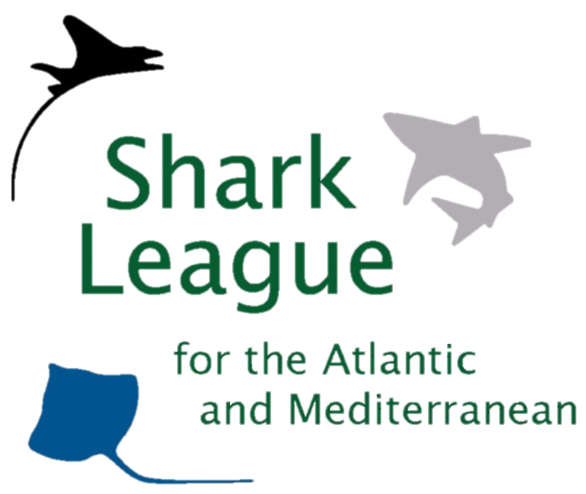

PRESS RELEASE

Scientists Report on Mako Shark Overfishing, Advise North Atlantic Ban
Conservationists call on fishery managers to act, prohibit landings in November

London. 11 October 2017. Scientists associated with the International Commission for the Conservation of Atlantic Tunas (ICCAT) today released their report on the status of Atlantic mako shark populations, revealing serious overfishing and depletion in the North Atlantic. New analyses show that the North Atlantic mako population has a 54% chance of recovering by 2040 if catches are cut to zero, leaving scientists to recommend a complete and immediate ban on retaining shortfin makos from the region, as well as measures to reduce the mako mortality associated with accidental catches. The scientists’ advice will be presented to fishery managers for possible action at the ICCAT annual meeting in November.

"Shortfin makos are among the most vulnerable and valuable sharks taken in high seas fisheries, and are long overdue for protections from overfishing,” said Sonja Fordham, President of Shark Advocates International, a project of The Ocean Foundation. “North Atlantic makos are now in a dire state, requiring decisive action, including a prohibition on retention and landing, in line with new advice from scientists.”

The shortfin mako – the world’s fastest shark -- is sought for meat, fins, and sport, but most fishing nations have yet to impose limits on catch. The first mako population assessment in five years was conducted by scientists over the summer; their final report and advice was released today.

“For far too long, the top mako fishing nations – Morocco, Spain, and Portugal – have landed this vulnerable species without limit, and the result is a disaster,” said Ali Hood, Shark Trust, Director of Conservation. “These and other countries must now step up and put mako sharks on the path to recovery, starting with proposals for ICCAT to agree immediate protections at their annual meeting next month.”

Morocco will host the 2017 ICCAT meeting in Marrakech, November 14-22. ICCAT comprises 50 countries and the EU. ICCAT has adopted bans on retaining other shark species taken in tuna fisheries, including the bigeye thresher and oceanic whitetip shark. Studies show makos released alive from hooks have a 70% chance of survival, meaning a ban on retention could be an effective conservation measure.
The assessment of South Atlantic makos was highly uncertain and therefore warrants a particularly precautionary approach. ICCAT scientists have recommended a catch limit that reduces landings, while conservationists advise a ban, given the vulnerability of the species and lessons from the North Atlantic.
Media contact: Sophie Hulme, email: sophie@communicationsinc.co.uk; telephone: +447973712869.

Notes to Editors:
Shark Advocates International, Shark Trust, Ecology Action Centre, and Project AWARE have formed the Shark League for the Atlantic and Mediterranean, a coalition dedicated to responsible, science-based regional shark conservation: www.sharkleague.org .
The new ICCAT report containing population assessments and management advice for sharks and other highly migratory Atlantic fish can be accessed here: https://www.iccat.int/Documents/Meetings/Docs/2017_SCRS_REP_ENG.pdf
Female shortfin makos mature at 18 and usually have 10-18 pups every three years after a 15-18 month gestation.

A 2012 Ecological Risk Assessment found makos exceptionally vulnerable to Atlantic pelagic longline fisheries.

